

**COSC 484 – Web Engineering**

**Project Documentation**

**Hope Sanctuary**

**Submitted By:**

Noor Alarab,

Dana Barhoom,

Rawan Albinzayed

**Date:**

January 6, 2025

# Table of Contents

Table of Contents 2

1. Introduction 4

Project Summary 4

2. Specifications 4

Objectives and goals 4

3. Requirements 4

Functional Requirements 5

Non-functional Requirements 5

Technology Stack 6

Core Features 6

Audience Analysis 7

4. Design 7

Design strategy 7

Wireframe 8

Prototype 8

5. Testing 9

Testing Methods 9

Testing Tools 9

6. Report and Results 9

Website pages 9

Key Findings 15

Challenges Encountered 16

Solutions Implemented 16

*7.* Technical Guide 17

8. Teamwork and Contribution 17

9. Summary and Future Scope 18

Summary 18

Future Scope 18

10. Manuals 19

End-User Guide 19

1. Login in with an existing account 19

2. Registering an Account 19

3. Browsing Pet Profiles 20

4. Submitting an Adoption Request 22

5. Contact the staff 22

Admin Guide 22

1. Add a pet 22

2. Edit a pet 23

3. Delete a pet 25

4. View and change status of adoption requests 26

# Introduction

## Project Summary

This project aims to develop a comprehensive and user-friendly pet adoption platform that will improve the efficiency and accessibility of adoption processes for both animal shelters and potential pet owners. The portal has a simple interface for browsing adoptable animals and filtering them by breed, species, and age. It also offers step-by-step adoption instructions and instructional content regarding proper pet ownership. It makes it easier for organization staff to handle animal profiles and track adoption requests, resulting in increased operational efficiency.

# Specifications

## Objectives and goals

The platform's major goal is to promote responsible pet ownership while also streamlining the adoption process. The main objectives of the website are:

* Allow users to view pets available for adoption.
* Allow users to submit adoption requests for the available pets.
* Allow users to contact the shelter or sanctuary through a contact form.
* Use user authentication to have admin users with access to admin dashboards.
* Provide admins with a admin dashboard so they can add, edit and delete the available pets.
* Allow admins to see all the adoption requests that have been submitted and allow them to edit the status of a request to enable request management.

By fulfilling these objectives, the project aims to achieve the following goals:

* Decrease the number of animals in shelters.
* Create a friendly network for pet lovers and adopters.
* Provide shelters with current technologies to run operations more efficiently.

# Requirements

## Functional Requirements

1. User Authentication and Management

* User authentication this includes user registration or as the Sign Up and Logging In function is required for all users of the website.
* Password management is also required to enable password recovery and password storage for Authentication.
* Includes account management to allow users to update their personal information of their accounts on the website.
* A function of keeping the users logged in, with options for auto-logout after being inactive to ensure security.

1. Navigation and State Management

* A dynamic navigation functionality is a clear and responsive navigation structure that is consistent throughout the platform.
* This function is useable by all users of the website.

1. View Pet details:

* This functional requirement is usable by users who wish to adopt a pet.
* Listing details display functionality would be present to show detailed descriptions, images, and other profile details for each pet.

1. Form submission:

* Form placement is a functionality that would enable users that want to adopt a pet, to submit a form for their favorite pet to send request for adoption.

1. Searching:

* Functionality of allowing users to search for specific pets by name, breed and species.

1. Admin dashboard:
   * Functionality of an admin dashboard which allows admins to managed available pets.
   * The functionality to add, edit and delete pet listings by admins only.
2. Adoption request management:
   * Functionality of allowing admin to track adoption request submitted by users.
   * Request management functionality to allow admins to edit status of adoption forms such as accepting or rejecting a request.
3. Codebase and Database Management

* Functionality of maintaining an organized codebase.
* Implement a database structure for users, forms, pet listings, and reviews.

## Non-functional Requirements

The non-functional requirements include:

* **Performance:** The load speeds and responsiveness was given top priority on the website.
* **Scalability:** As the user base and workload increase, the website is able to accommodate the additional demands.
* **Compatibility and Portability:** The website can work with many different screen sizes and situations.
* **Availability and Reliability:** The website was able to have as minimal interruptions or failures as possible.
* **Security:** Unauthorized access is prevented by the website.
* **Usability:** With an intuitive and accessible design, the website maintains a high priority on user accessibility and simplicity of use.

## Technology Stack

**Frontend**

* Framework: The use of React.js, an open-source JavaScript runtime environment and library, was the framework for the frontend.
* For designing the website, it was done through the use of CSS and Bootstrap 5.
* The Response of the Design: To construct a design that is completely responsive across various screen sizes, the website made use of CSS frameworks such as Bootstrap.

**Backend**

* Framework: Handlebars and Express.js is used for dynamically displaying website elements like lists and templating the site.
* Database: MongoDB, a non-relational database with great read and write performance and data stored in BSON format for simpler JavaScript and JSON compatibility, was used for the databases.
* API: To make it easier to integrate with the database and carry out tasks like retrieving and sending data to the server and database, RESTful API was utilized. API procedures like GET, POST, PUT, PATCH, and DELETE are used to do this.
* Unit Testing: To complete the test cases for the forms submitted, Jest was the method used to complete the unit test cases.
* Deployment:The deployment was done onAWS (Amazon Web Services).

## Core Features

* **User Authentication and Security**: A reliable system allowing secure registration, login, and password recovery. Persistent login ensures convenience, while session expiration enhances security.
* **Seamless Navigation**: A responsive and intuitive design ensuring effortless interaction across devices.
* **Pet Listings**: Comprehensive animal profiles featuring details such as age, breed, health status, and temperament, with advanced filters for refined searches.
* **Guided Adoption Workflow**: Streamlined steps for submitting and monitoring adoption requests, ensuring transparency and ease.
* **Feedback and Review Mechanism**: Users can share their experiences and provide suggestions for continuous platform improvement.
* **Technical Robustness**: Backend systems ensure efficient data handling, while APIs facilitate smooth communication between components.

## Audience Analysis

* **Animal Enthusiasts**: Prospective adopters looking for a variety of options.
* **Pet Owners**: Individuals seeking expert advice and resources for pet care.
* **Animal Shelters**: Organizations needing tools to manage adoption inquiries and showcase their animals.
* **Volunteers and Service Providers**: Professionals and volunteers interested in collaborating with shelters.
* **Educational Institutions**: Schools and nonprofits aiming to promote awareness about animal welfare.

# Design

The design phase of the website was the stage at which the visual and interactive elements of the site are conceptualized and prototyped. The design was created with the purpose and audience in mind with an emphasis on a user experience that prioritized ease of access and intuitive navigation.

## Design strategy

The design strategy chosen for this project focused on the purpose on the website which is to be an adoption website whose purpose is to attract users to adopt pets and facilitate the adoption process.

The color scheme chosen for the website is a colorful scheme which uses the color blue as a base color with accents of bright colors. The bright colors were chosen to attract user attention to pets and provide a cheerful and hopeful atmosphere. For the typography, one clear font was used to enhance readability.

UI elements such as action buttons were given bright colors that reflect the purpose of the button to help guide the user actions. For example, bright red was used for the delete buttons to emphasis that action that the button performs.

The design placed a clear emphasis on the pets available, placing them front and center in the home page and using large pictures of the pets to attract the users attention.

## Wireframe

The wireframe of the website was created using Figma. The wireframe is a mid to high fidelity outline of the structure of the website. The wireframe focused on the layout of important elements such as the navigation bar, pet cards and forms.

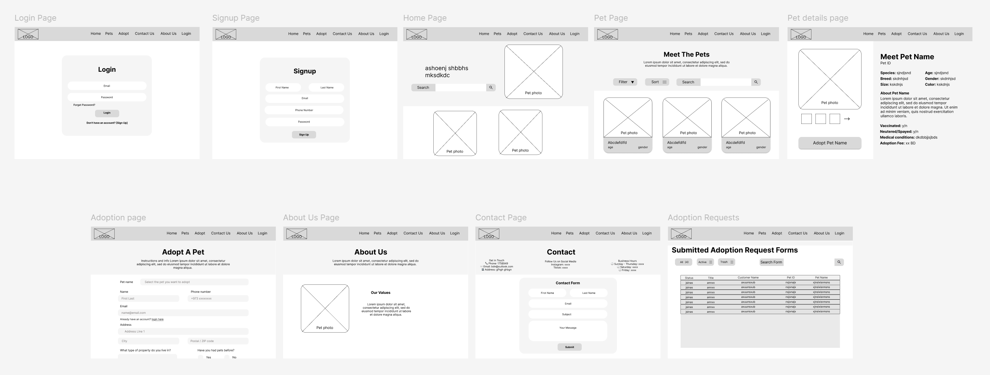

## Prototype

The prototyping was also done using Figma. It outlines the detailed design outlook of the website focusing on the colors and the design appearance that will be used for the different pages involved. The Prototype shows the different pages that are involved with accordance to the wireframing.

The prototypes was also interactive with clickable buttons and working navigation bar. It simulated a working website and gives an idea of how user interaction and the website functionalities would work on the final product.

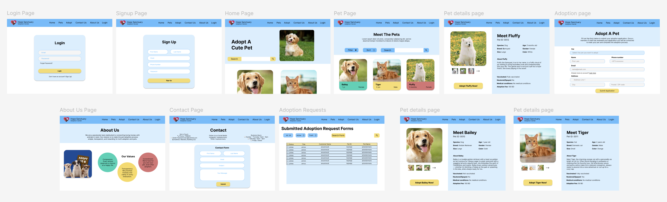

# Testing

## Testing Methods

Testing was conducted on the website to ensure functionality and discover errors. The first method of testing that was used was white box testing where the team tested all the pages and functionalities of the website. In addition to this, black box testing was also used where members of the family where asked to perform different tasks on the website to ensure the functionality. Moreover, unit testing was used to further test the website.

## Testing Tools

* **Cypress**: Facilitated automated end-to-end tests, validating critical user flows and identifying potential issues early.
* **Jest**: Provided robust unit testing capabilities, ensuring the reliability of individual components and functions.

# Report and Results

## Website pages

The resulting website consists of 12 pages which ensure that the website fulfils all its requirements, objectives and goals. The pages include 4 pages which are accessible by admins only which is enforced through user authentication. The website pages are as follows:

1. Home page: The main page of the website and is the landing page. Includes a search functionality and shows featured pets.

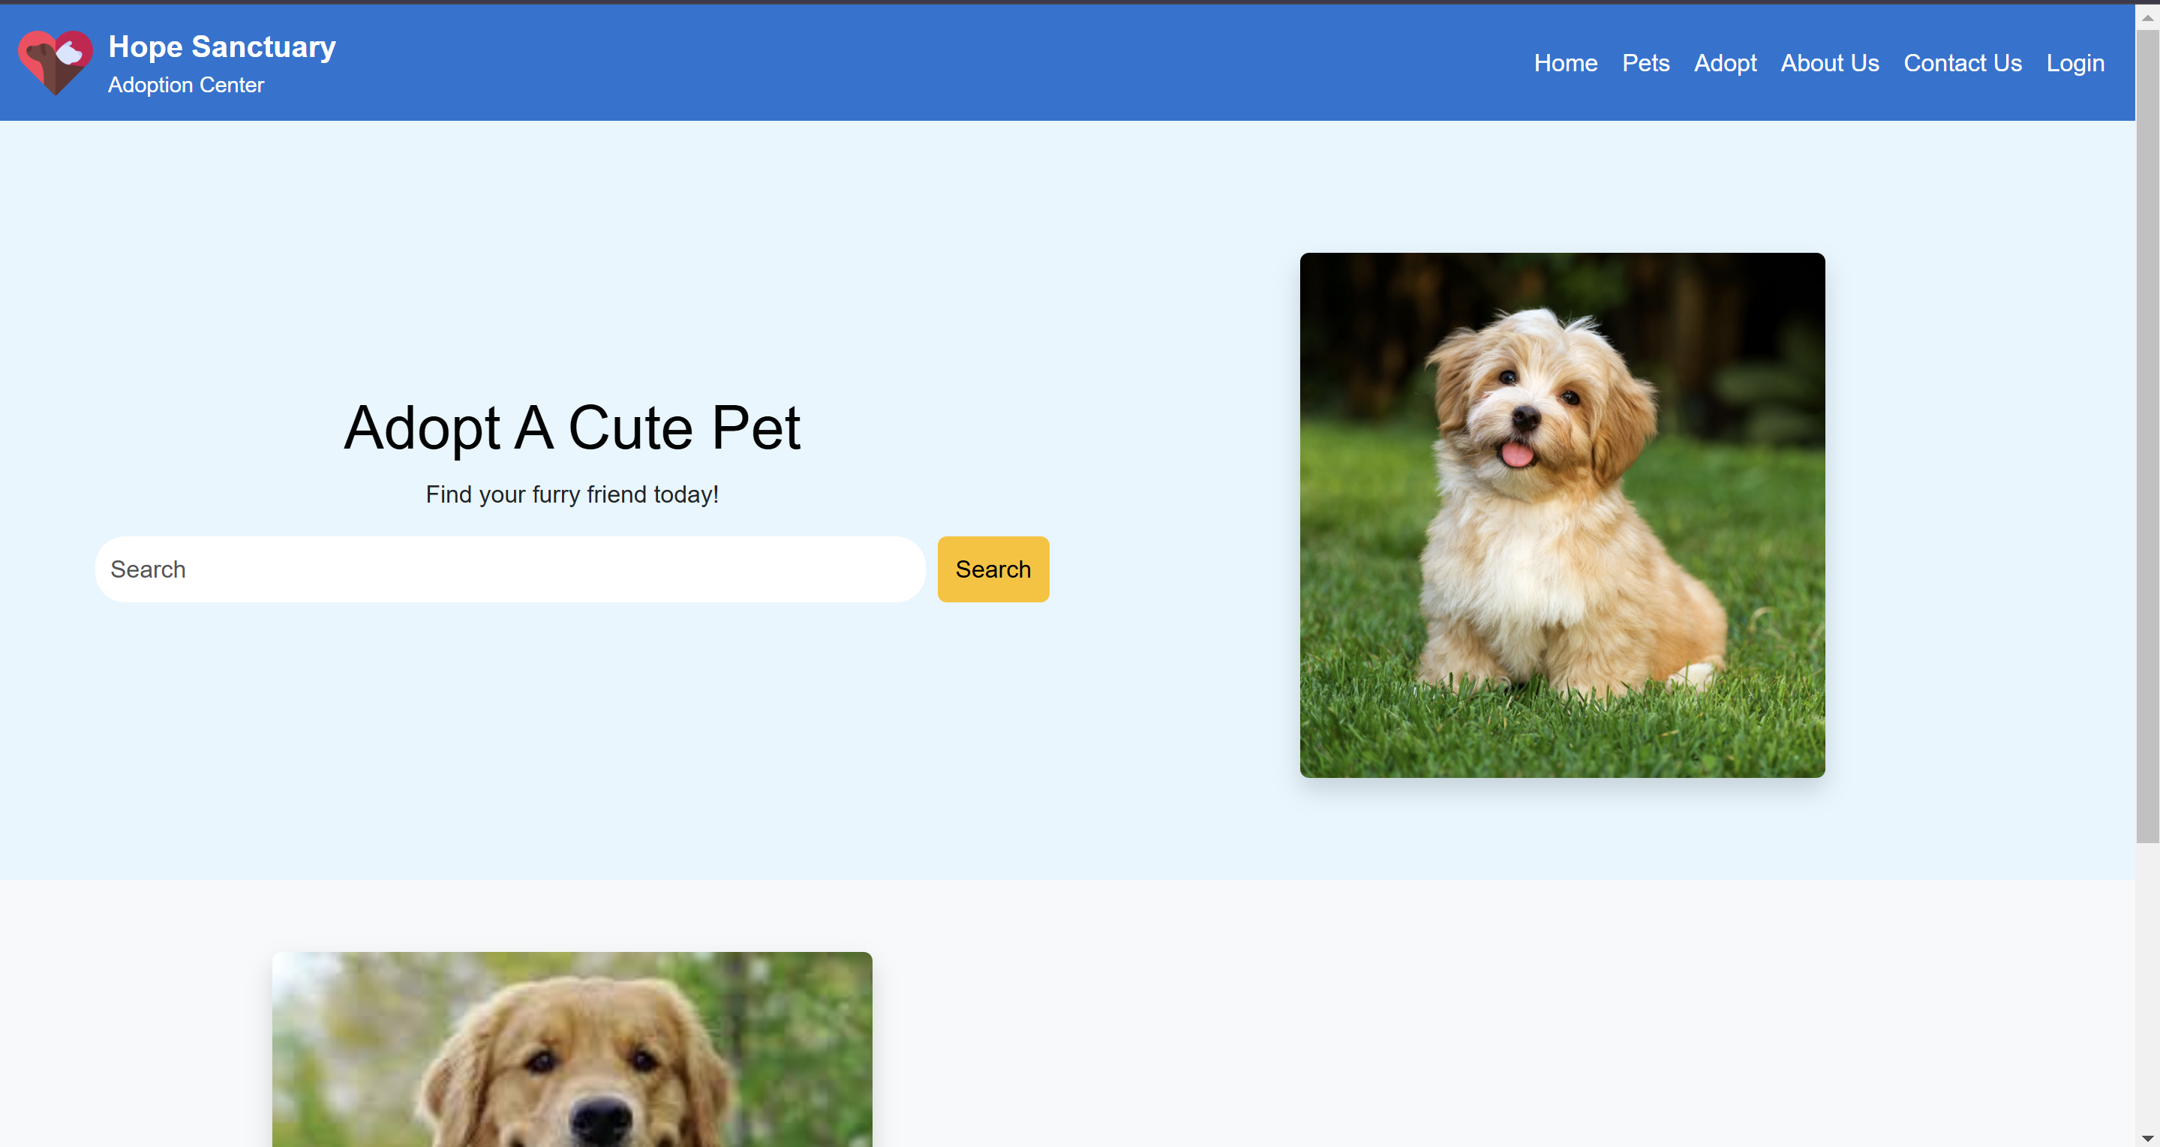

1. Pets page: This page shows all the available pets and allows users to search for pets by name breed and species.

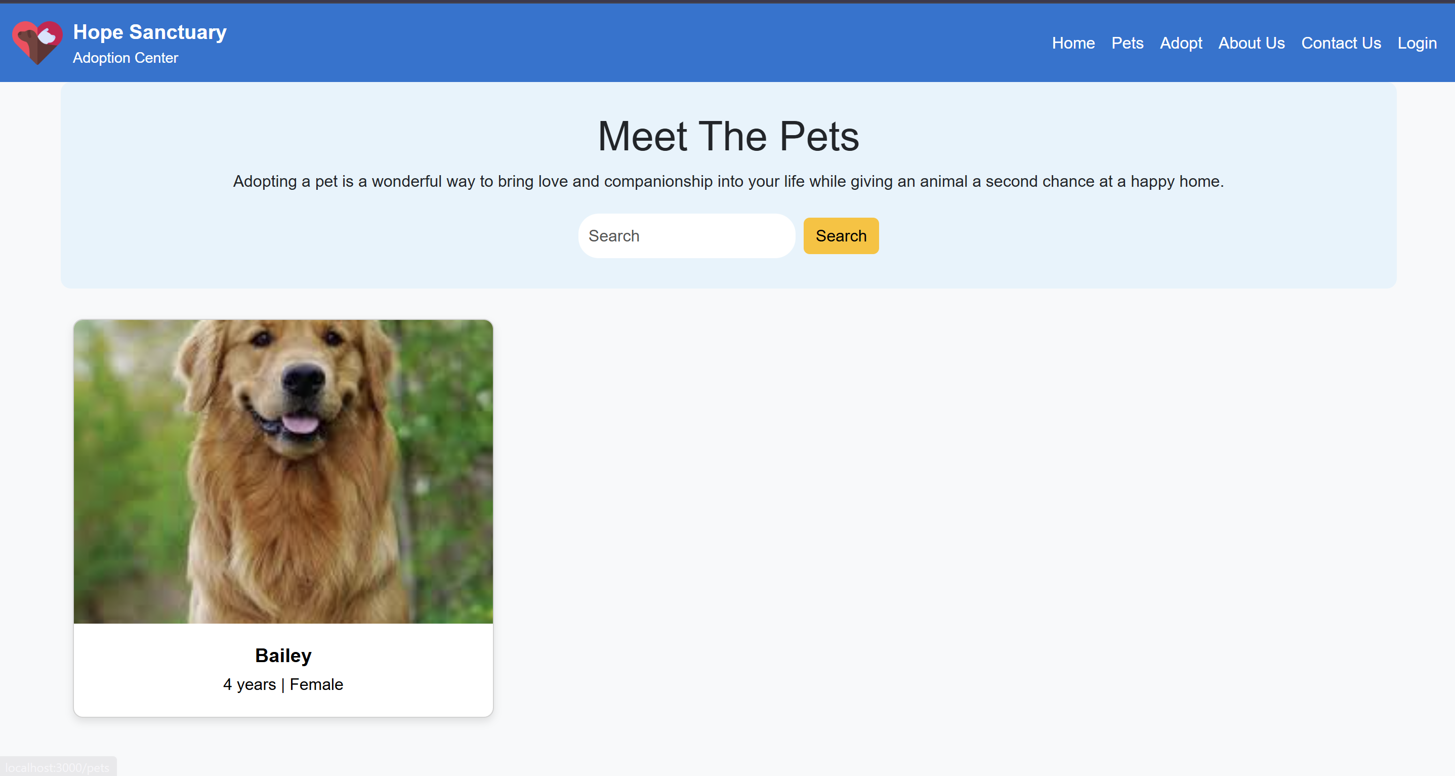

1. PetsDetails page: Accessed by clicking on a pet card and shows all the details of a pet.

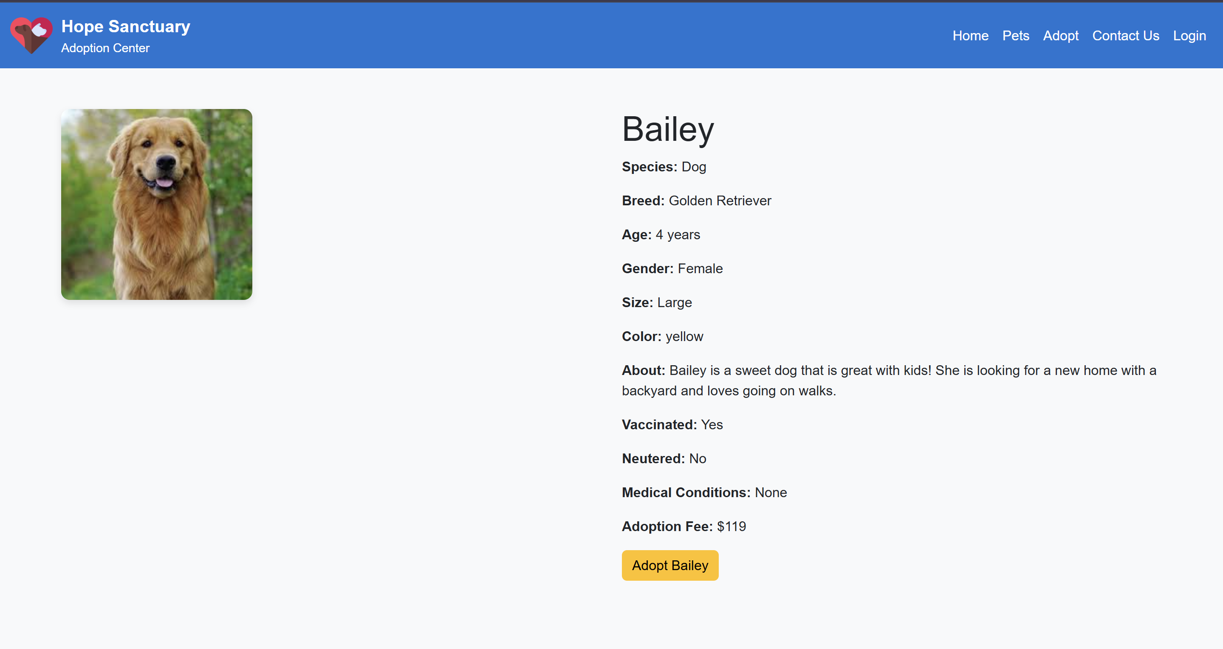

1. Adopt page: This page allows users to submit adoption requests through and adoption form.

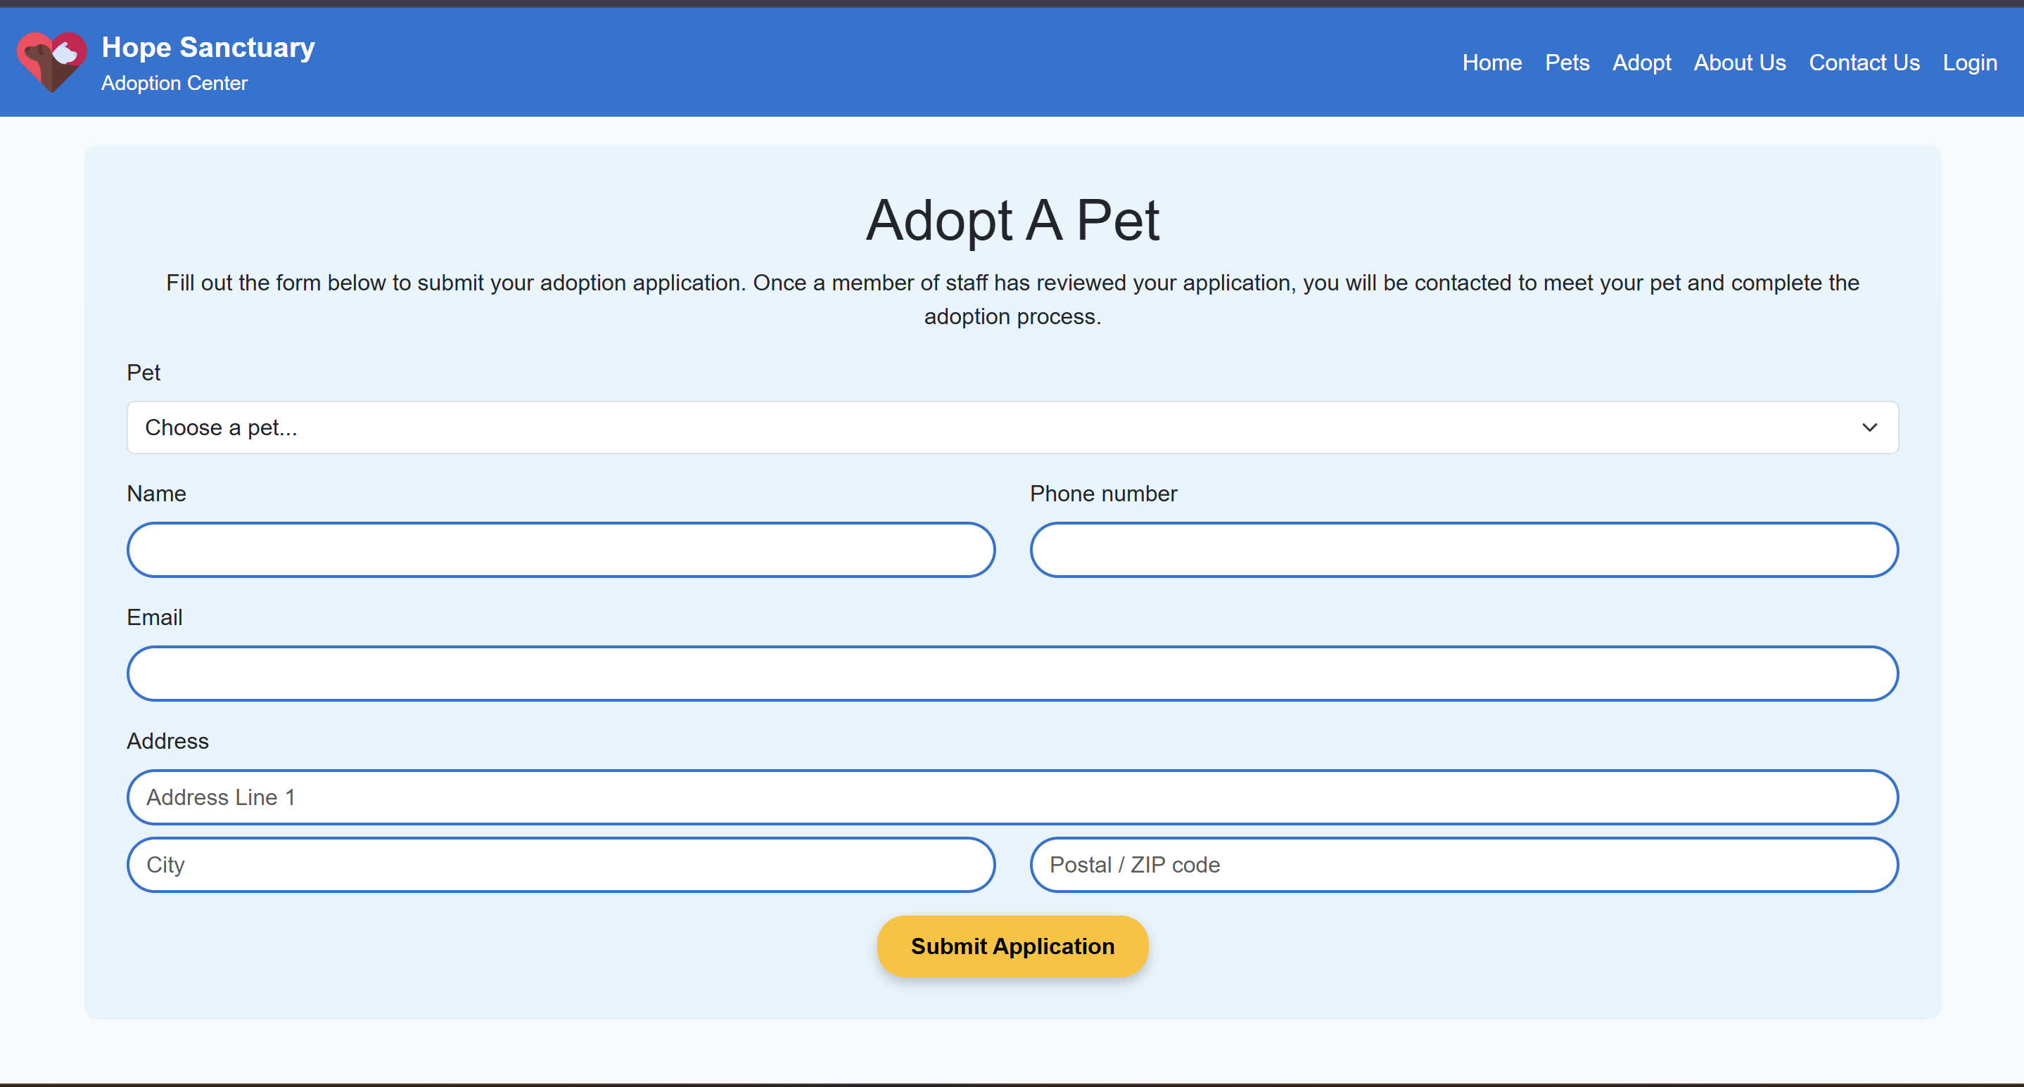

1. AboutUs page: Includes information about the sanctuary, who they are and their values and mission.

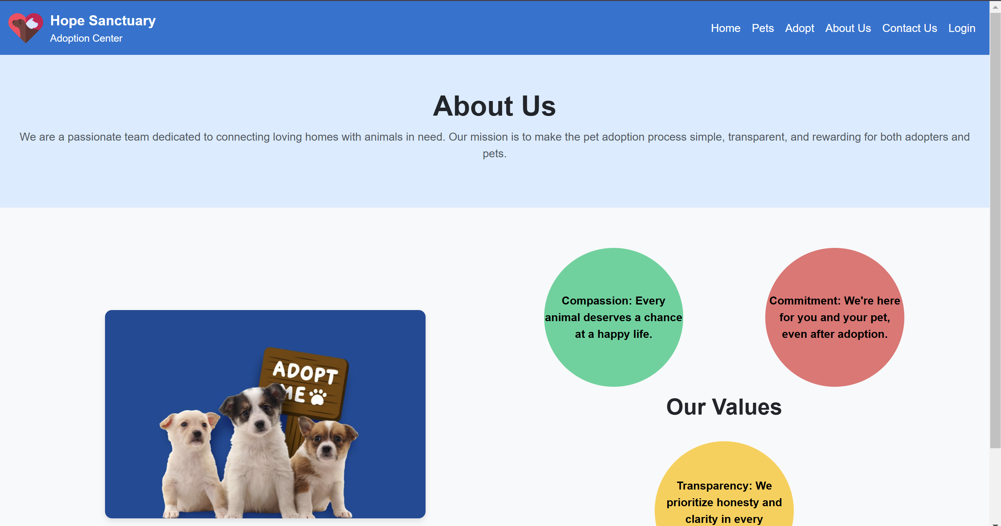

1. ContactUs page: Allows users to contact the sanctuary.

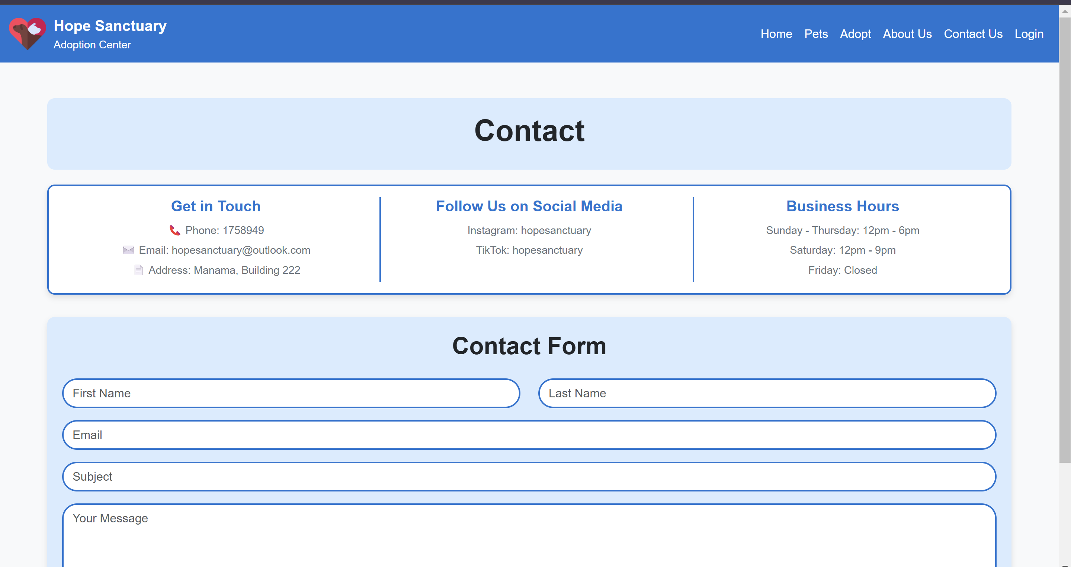

1. Login page: Enables users to login using an existing account or to signup.

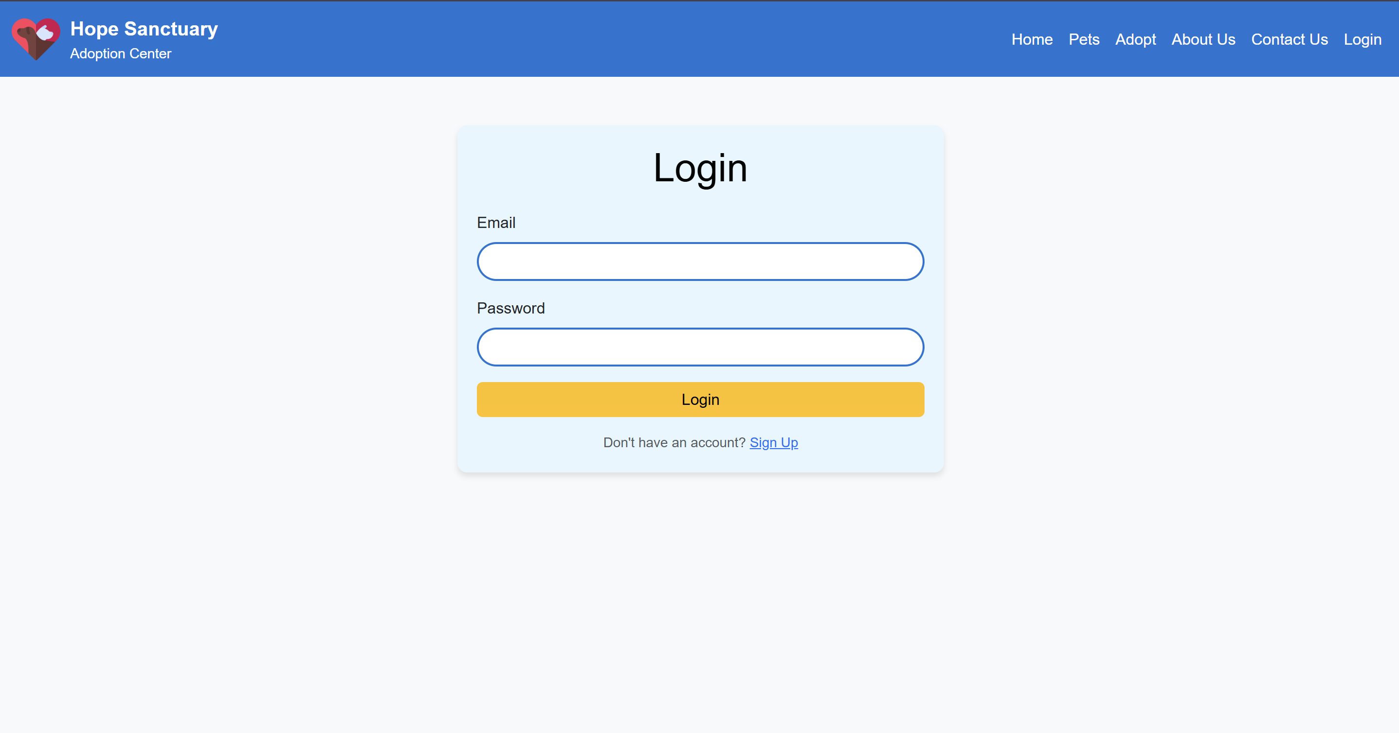

1. SignUp page: Lets users create a new account.

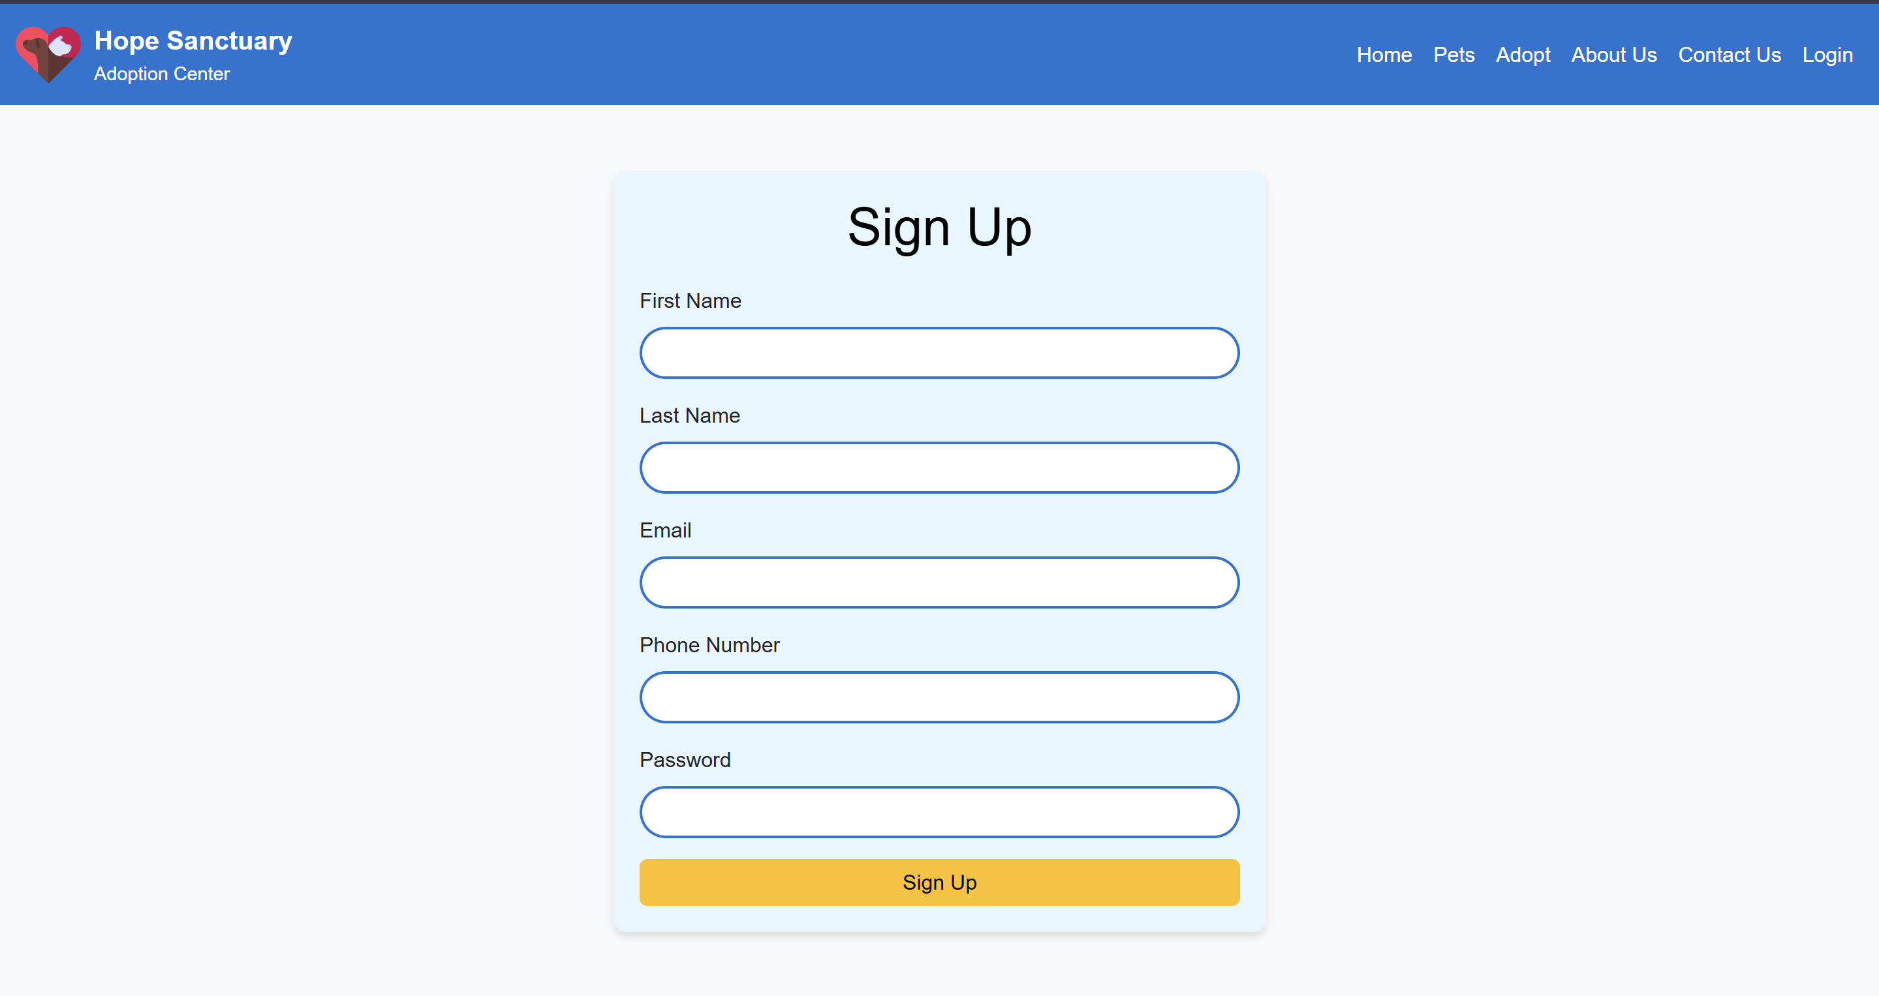

1. Requests page (Admin only): Shows the admins all the adoption requests and allows them to search and edit status

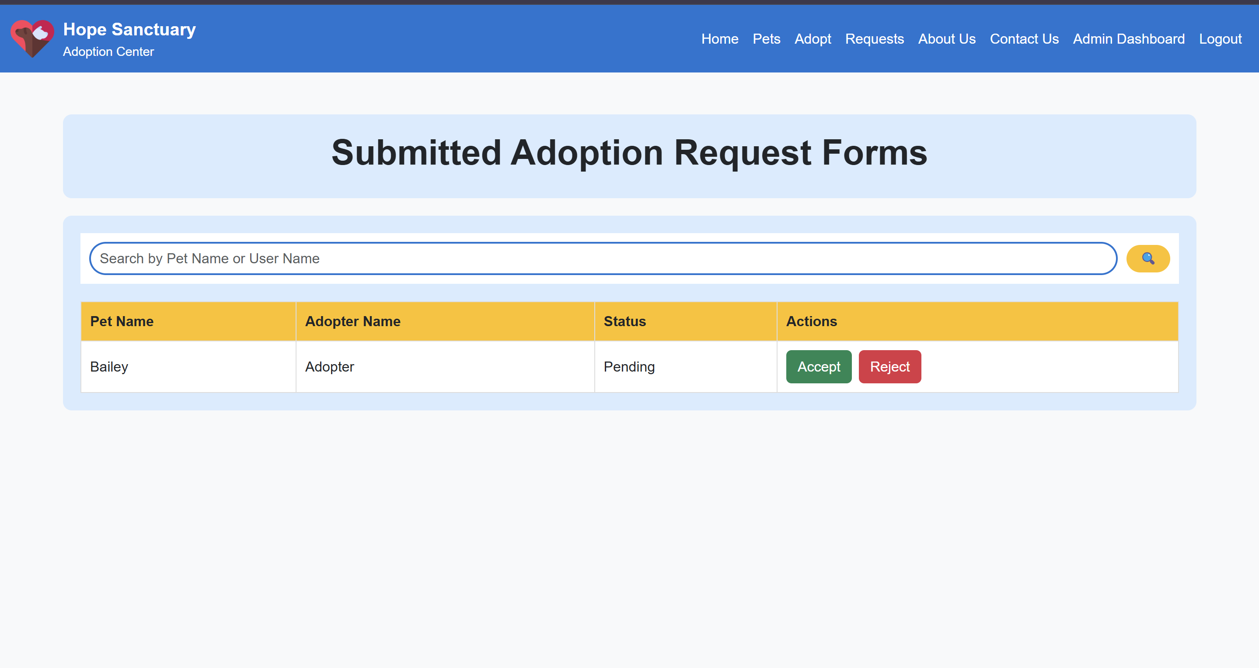

1. Admin page (Admin only): The admin dashboard allowing them to manage the pets.

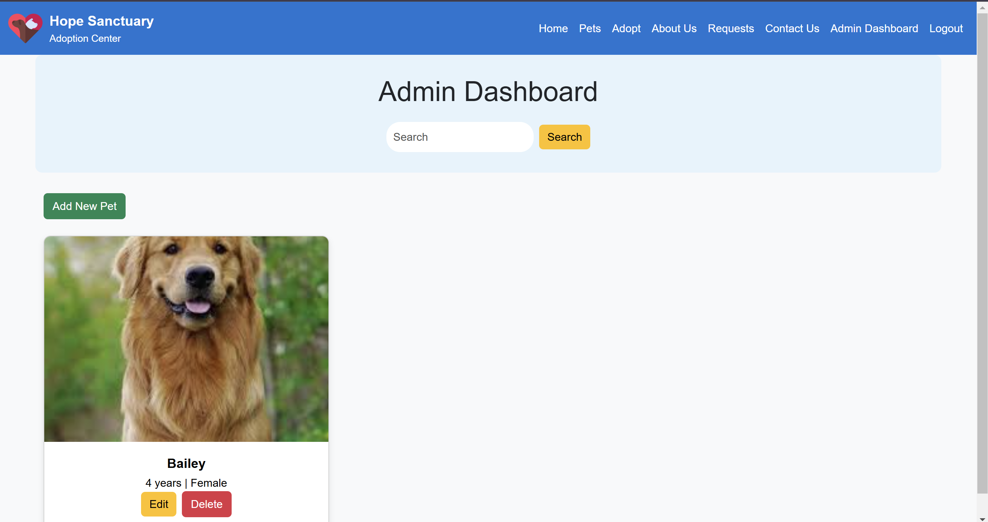

1. AddPet page (Admin only): Accessible through the admin dashboard providing a form to add a pet.

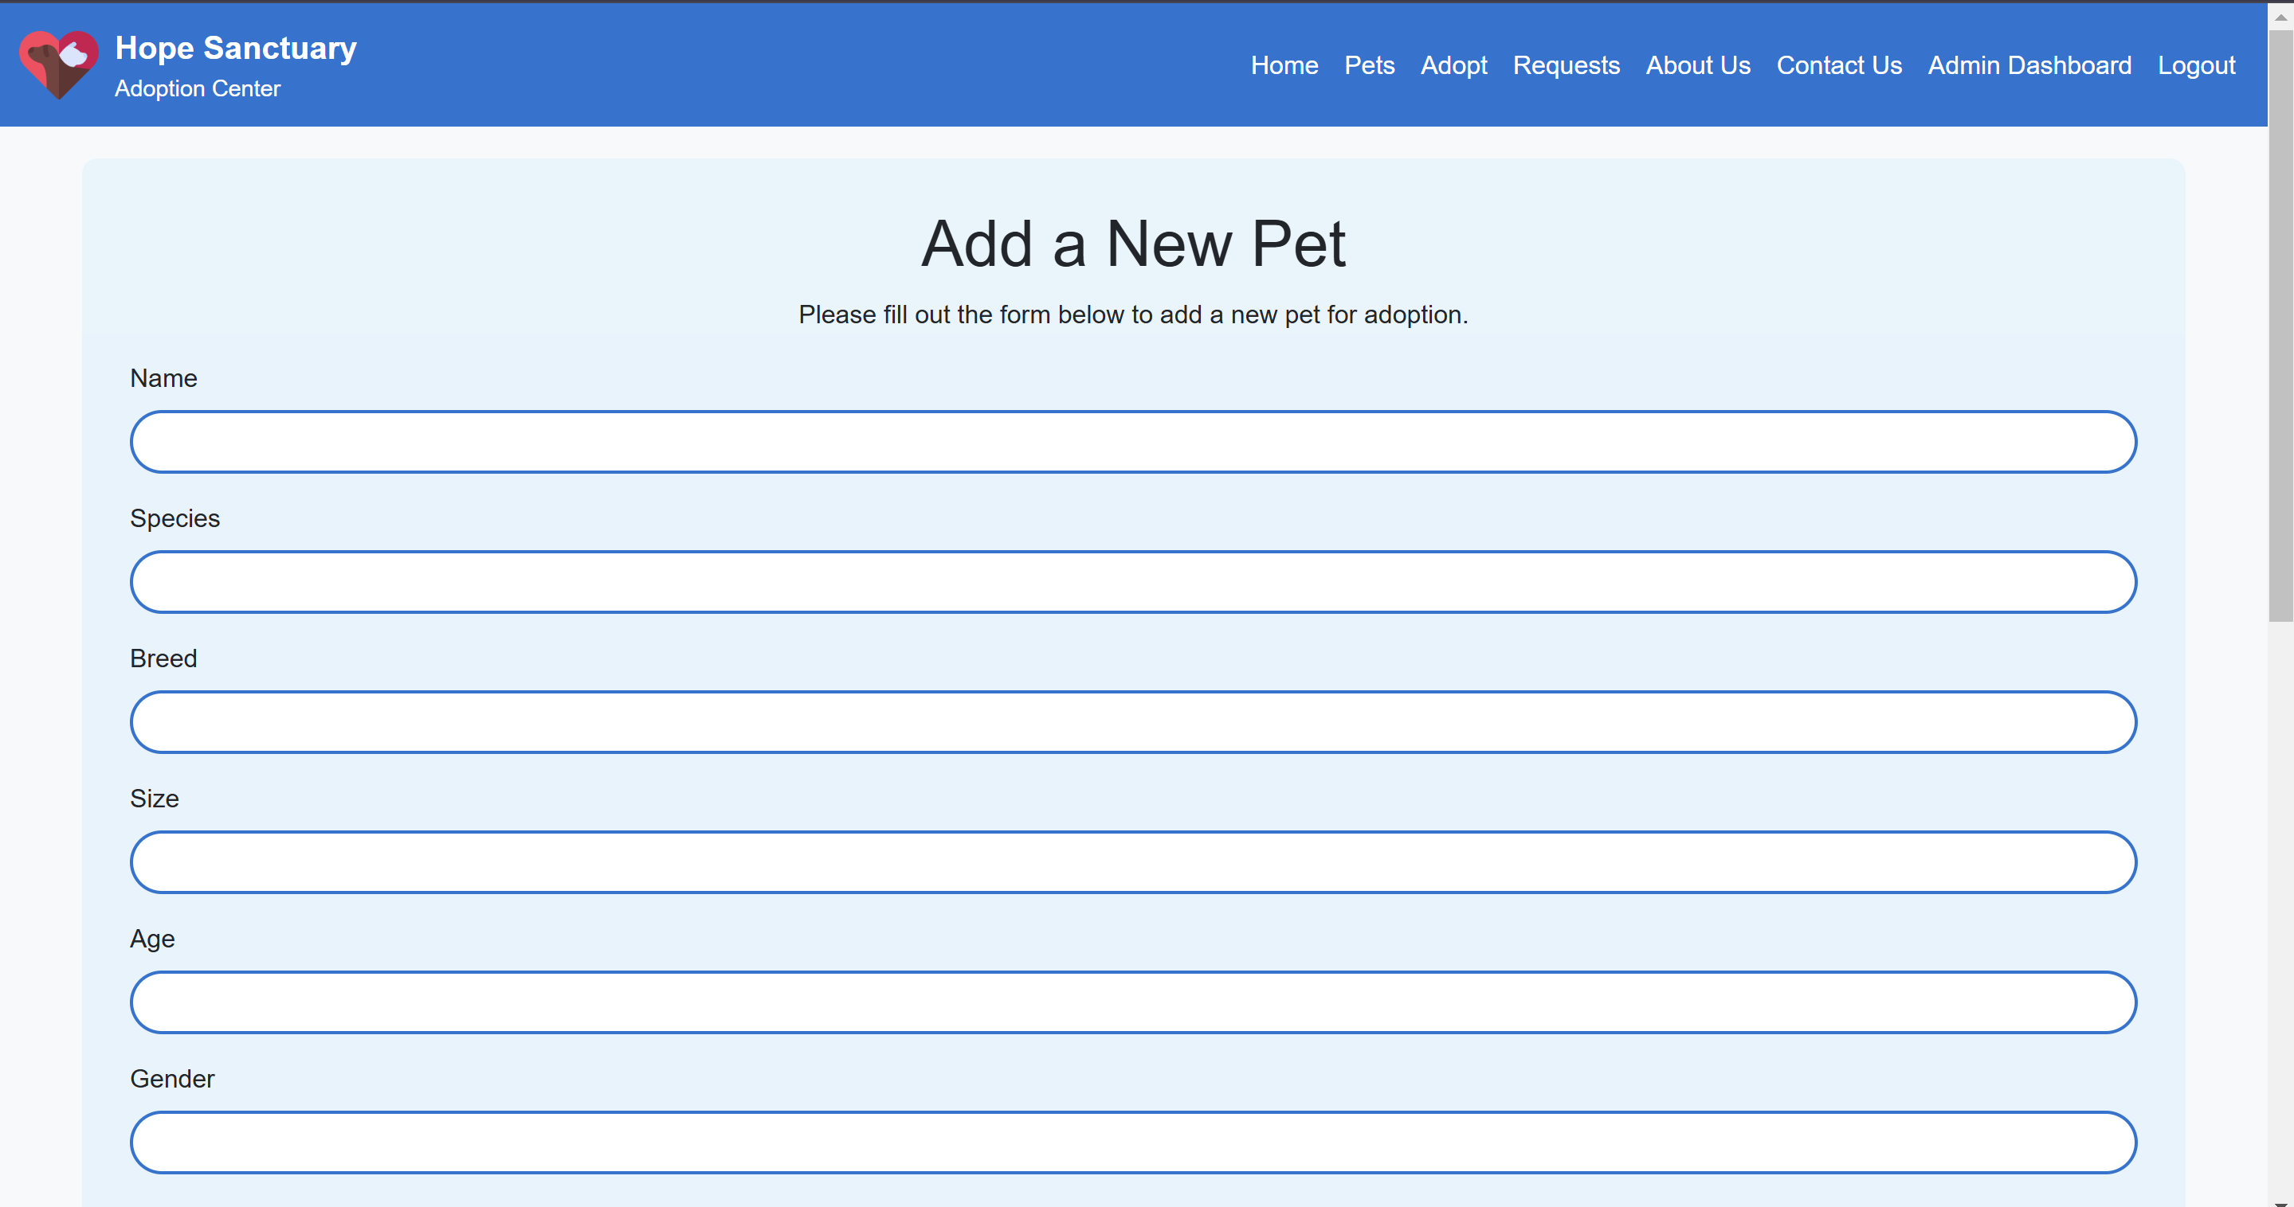

1. EditPet page (Admin only): Accessible through the admin dashboard, opens a form with the pets details and allows admin to edit the details.

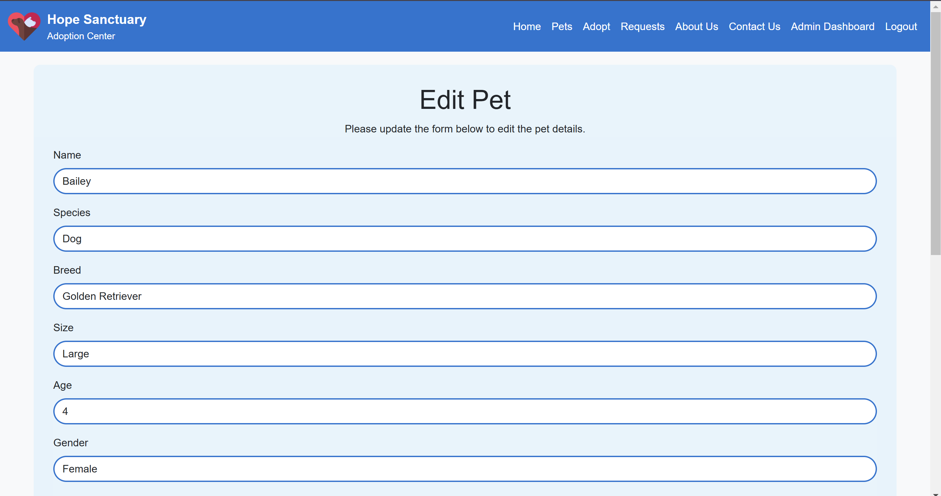

## Key Findings

* User-friendly workflows significantly enhance engagement, encouraging more adoptions.
* Streamlined tools empower shelters, improving communication and efficiency.
* Accessibility features expand the platform’s reach, making it usable for a diverse audience.

## Challenges Encountered

1. Technological Learning Curve: The team struggled to understand advanced frameworks and tools like React.js and MongoDB. Balancing learning and implementation while meeting tight timelines proved tough.
2. Limited access to specialized equipment and expertise caused delays in development and testing.
3. File Collaboration Issues: Early on in the project, sharing and synchronizing project files resulted in inefficiencies and miscommunication between team members.
4. Testing Strategies: Due to the team's lack of past expertise with Cypress and Jest, it took significant work to understand and utilize these testing tools efficiently.
5. AWS Deployment Challenges: Deploying the platform on AWS required resolving server configuration challenges, handling scaling needs, and debugging connectivity issues.

## Solutions Implemented

1. Technical upskilling: The team used online tutorials, documentation, and knowledge-sharing meetings to swiftly learn new technologies such as React.js and MongoDB.
2. Efficient Resource Management: Prioritizing tasks and using open-source tools helped to reduce resource restrictions while preserving quality.
3. GitHub Use: A centralized GitHub repository was implemented, enabling seamless version control, efficient code reviews, and collaborative updates.
4. Robust Testing Approach: The team used Cypress for automated end-to-end testing and Jest for unit testing to ensure platform resilience. Regular testing cycles detected and fixed issues before they became problems.
5. AWS Deployment Optimization: Problems were overcome by fine-tuning server configurations, utilizing AWS Elastic Beanstalk for scalability, and doing rigorous troubleshooting of deployment problems.

# Technical Guide

1. **Deployment**:
   1. Backend: Install Node.js, configure MongoDB, and deploy using AWS.
   2. Frontend: Use React.js with Bootstrap for a responsive design.
2. **API Integration**: Set up RESTful APIs for data exchange, including endpoints for user management, pet profiles, and adoption requests.
3. **Testing**:
   1. Execute Cypress tests using the npm run cypress command to validate workflows.
   2. Run Jest tests with npm test to check individual components and logic.
4. **Troubleshooting**:
   1. Address common deployment errors by checking server logs and database connectivity.
   2. Resolve UI inconsistencies through browser compatibility checks.

# Teamwork and Contribution

* The project was completed through the contribution of three team members Noor, Rawan and Dana.
* The means of communication was through the app, WhatsApp and creating a WhatsApp group, which enabled the team membersto communicate with each other and discuss the project division of work or any concerns with each other.
* The group would also meet before the Web Engineering class to discuss each other’s progress on each of their tasks. In addition, the team members may ask each other for help when any of them needed or would support each other on parts where one is weak at.
* The different parts involved in the project was divided among the three members. This includes the frontend, backend, and testing. The team members would discuss and agree on who is doing what and work on it before a specified date.
* Then the one who finished the task at hand would push their work onto GitHub, which is where all the work would be placed, to allow the other team member to work on their part. This is to make it easier to work from home on each person’s specified task and would facilitate the progress of the website.
* Each of the tasks were divided among the team members according to the table shown below:

|  |  |
| --- | --- |
| Task | Members |
| Prototyping | Rawan, Noor, Dana |
| HTML/CSS | Dana |
| Authentication | Noor |
| Frontend | Dana/Noor |
| Backend | Rawan |
| API | Noor |
| Testing | Dana |
| React | Dana |
| Deployment | Rawan |

# Summary and Future Scope

## Summary

This project delivers an intuitive and accessible platform to promote pet adoptions while addressing operational challenges for shelters. It has the functionality that would allow users to adopt pets from the adoption website. This is done through the use of secure systems, seamless navigation, and user engagement tools, to help enhance the overall adoption experience for the user. Completing the project included facing some challenges such as some learning curves, and collaboration issues with files when being pushed on GitHub. These issues were resolved through referring to online resources to and group meetings to resolve any technical issues being faced. Through great team effort the adoption website Hope Sanctuary was functional and running.

## Future Scope

* **Social Media Integration**: Broaden platform visibility by allowing users to share pet profiles directly on social media.
* **Mobile Application Development**: Extend accessibility to smartphones with a dedicated app.
* **AI-Powered Recommendations**: Offer personalized pet suggestions based on user preferences and previous interactions.

# Manuals

## End-User Guide

### **Login in with an existing account**

Step 1: Navigate to login.

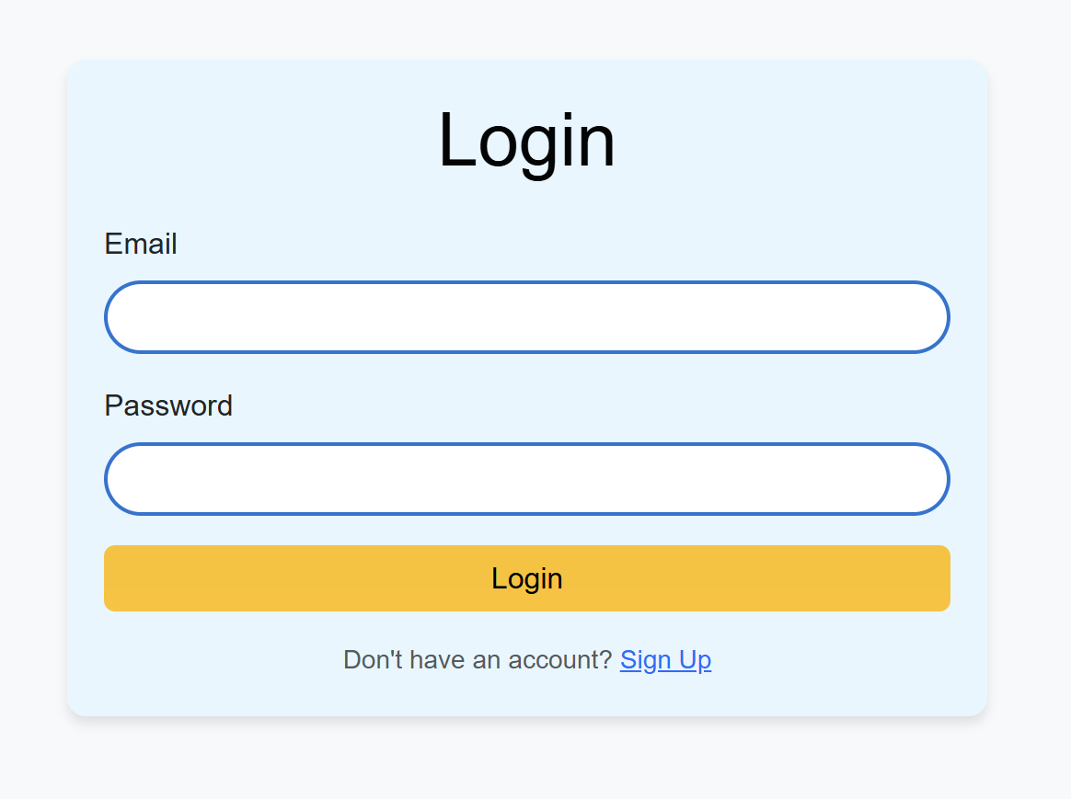

Step 2: Enter correct email address and password.

Step 3: Click on the login button to complete login.

### **Registering an Account**

Step 1: Navigate to login in page and click on signup link.



Step 2: Fill in the required information for a new account and submit the form.

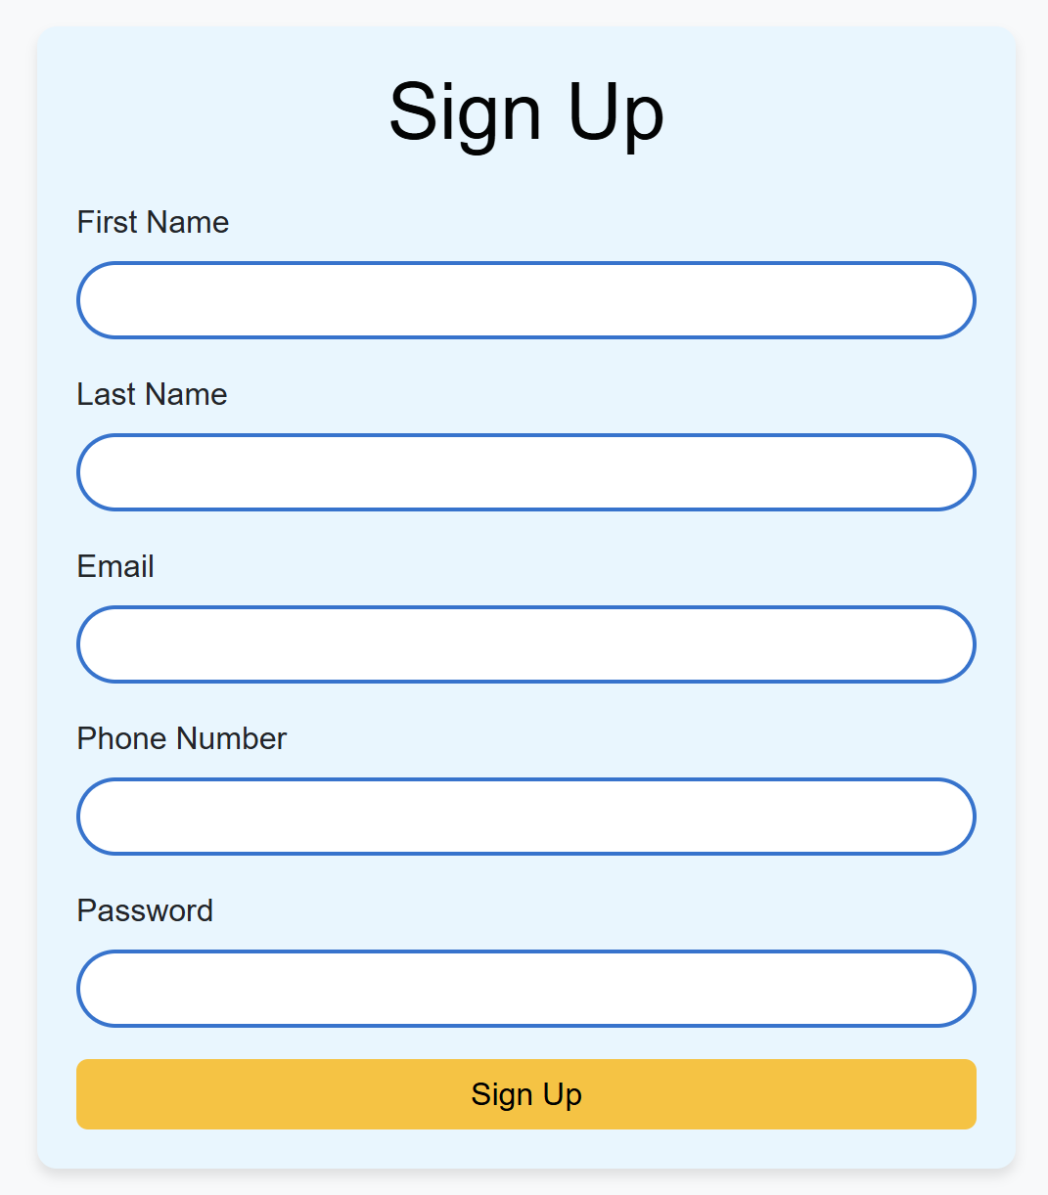

Step 3: Navigate to the login in page and login into the new account.

### Browsing Pet Profiles

Step 1: navigate to the pets page from the navigation bar.

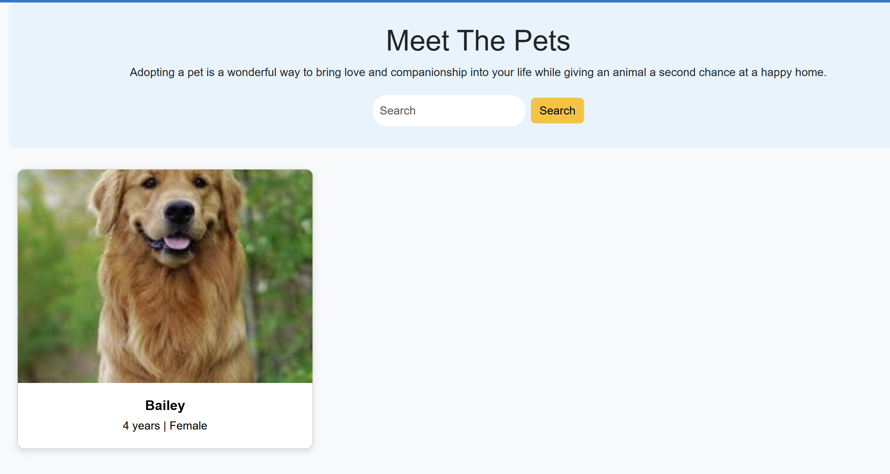

Step 2: If you are looking for a specific pet or a species, use the search bar to filter the results.

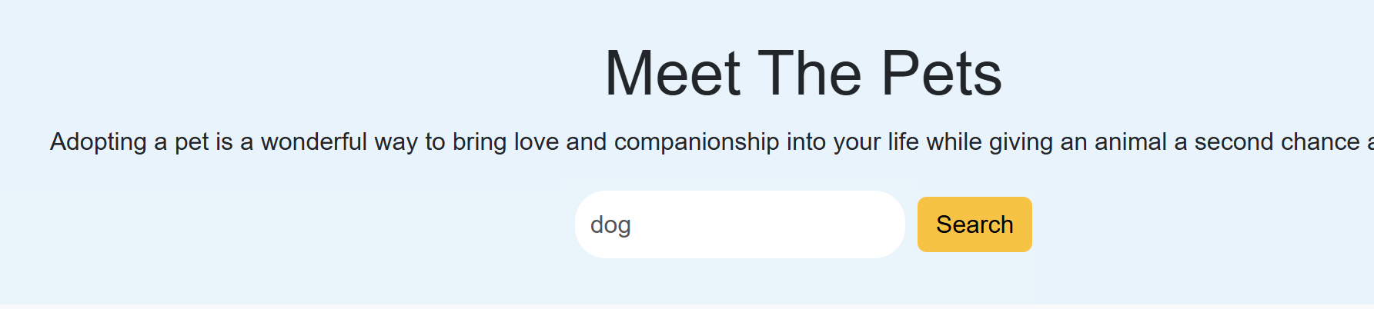

Step 3: Click on the pet picture to see the pet details.

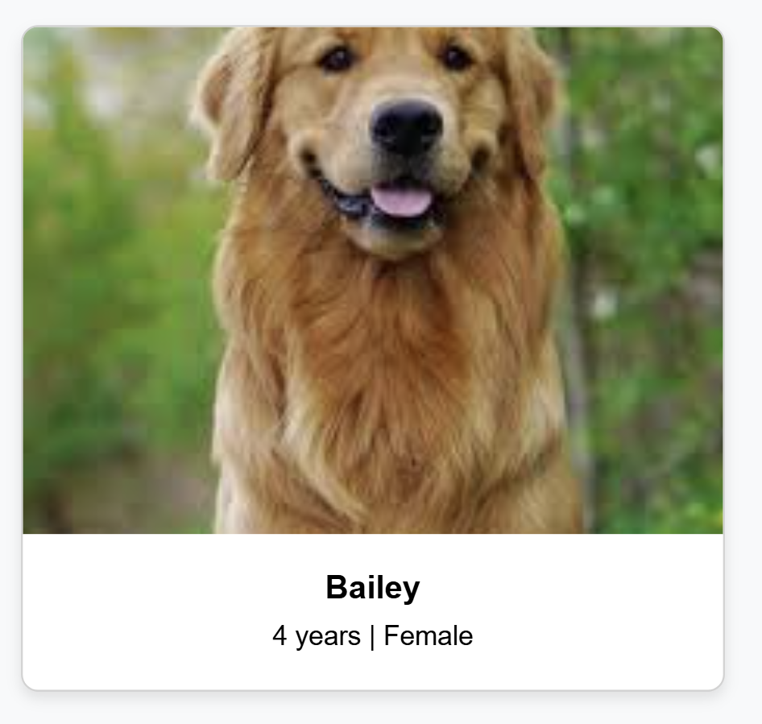

### Submitting an Adoption Request

Step 1: navigate to the adoption page from the navigation bar, make sure that you are logged in.

Step 2: Select the pet you want to adopt and fill in your information.

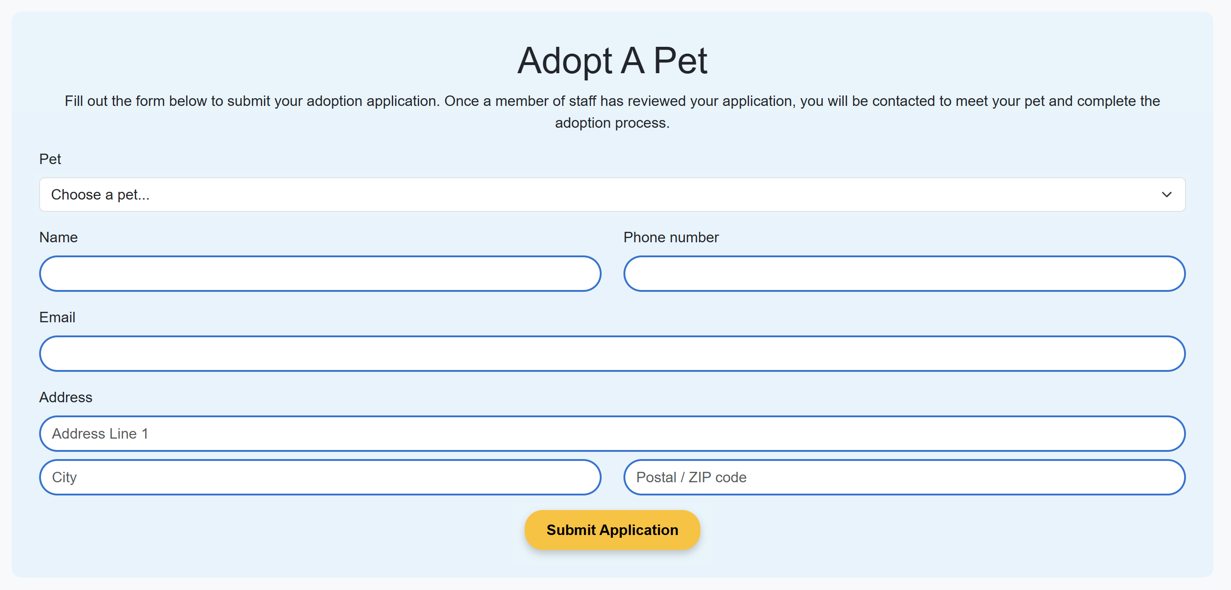

Step 3: Submit the adoption form.

### Contact the staff

Step 1: navigate to the contact us page.

Step 2: fill in your information and write the message you want to send to the staff.

Step 3: Submit the contact form.

## Admin Guide

### Add a pet

Step 1: login using the admin account. Refer to user guide above for login steps.

Step 2: navigate to the admin dashboard from the navigation bar.

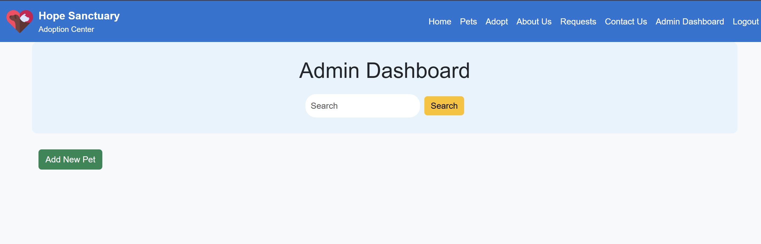

Step 3: click on the add pet button.

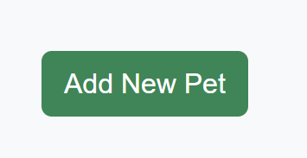

Step 4: fill in the required fields in the form for a adding a new pet.

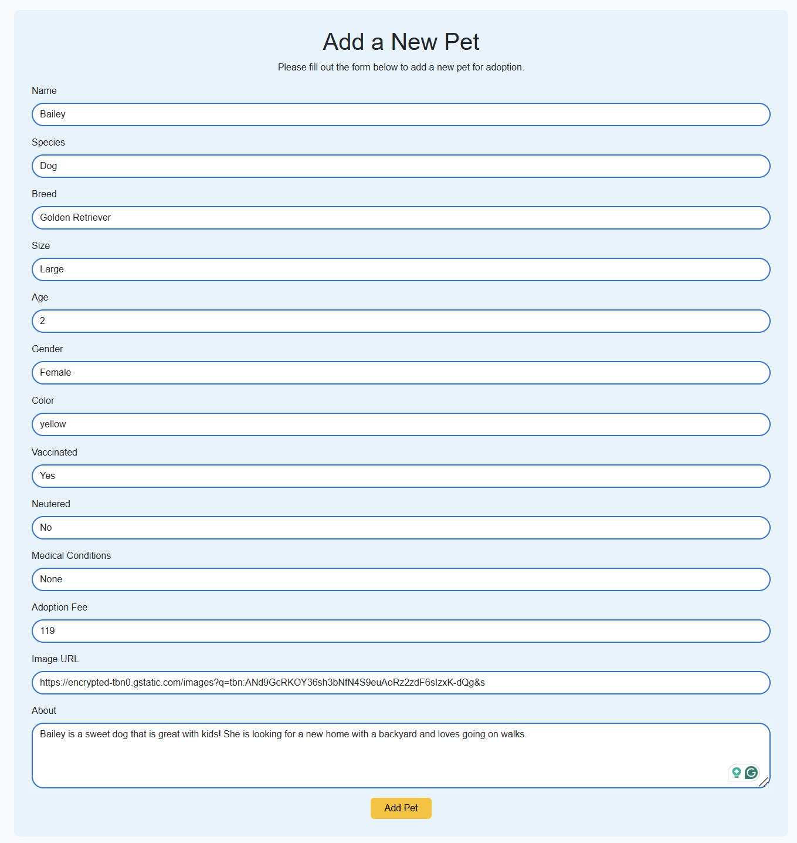

Step 5: submit the form and a new pet will be created.

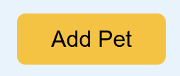

### Edit a pet

Step 1: login using the admin account. Refer to user guide above for login steps.

Step 2: navigate to the admin dashboard from the navigation bar.

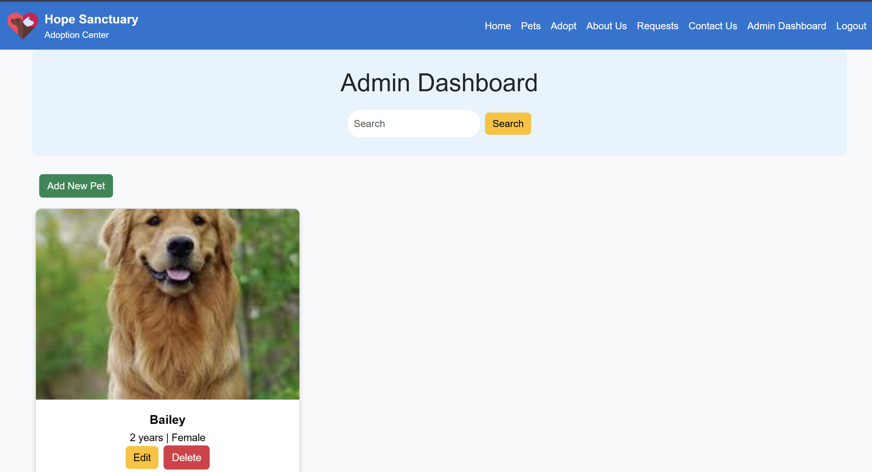

Step 3: click on the edit pet button that is under the pet picture.

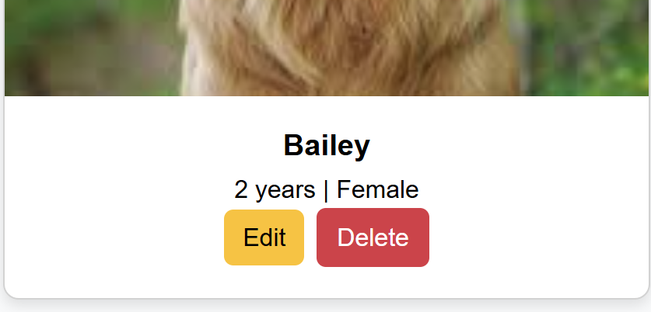

Step 4: change the data you want to edit in the pet edit form.

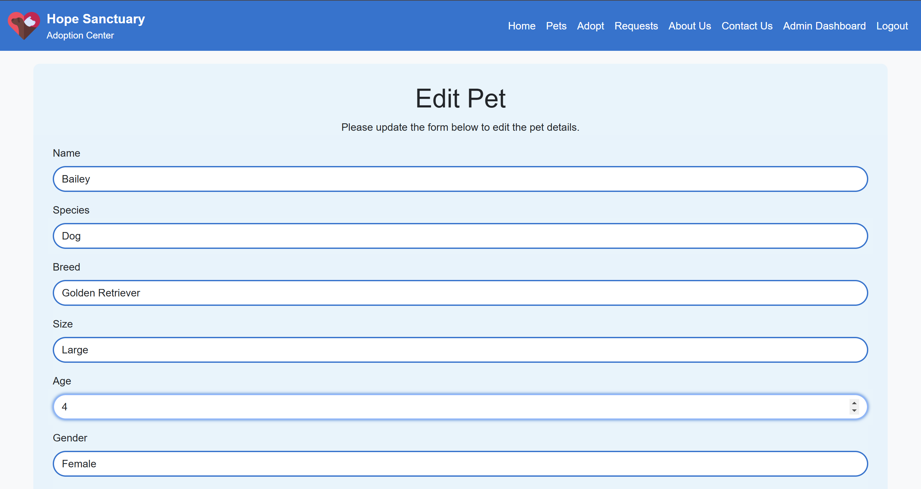

Step 5: submit the form and the pet information will be updated with the information in the form.

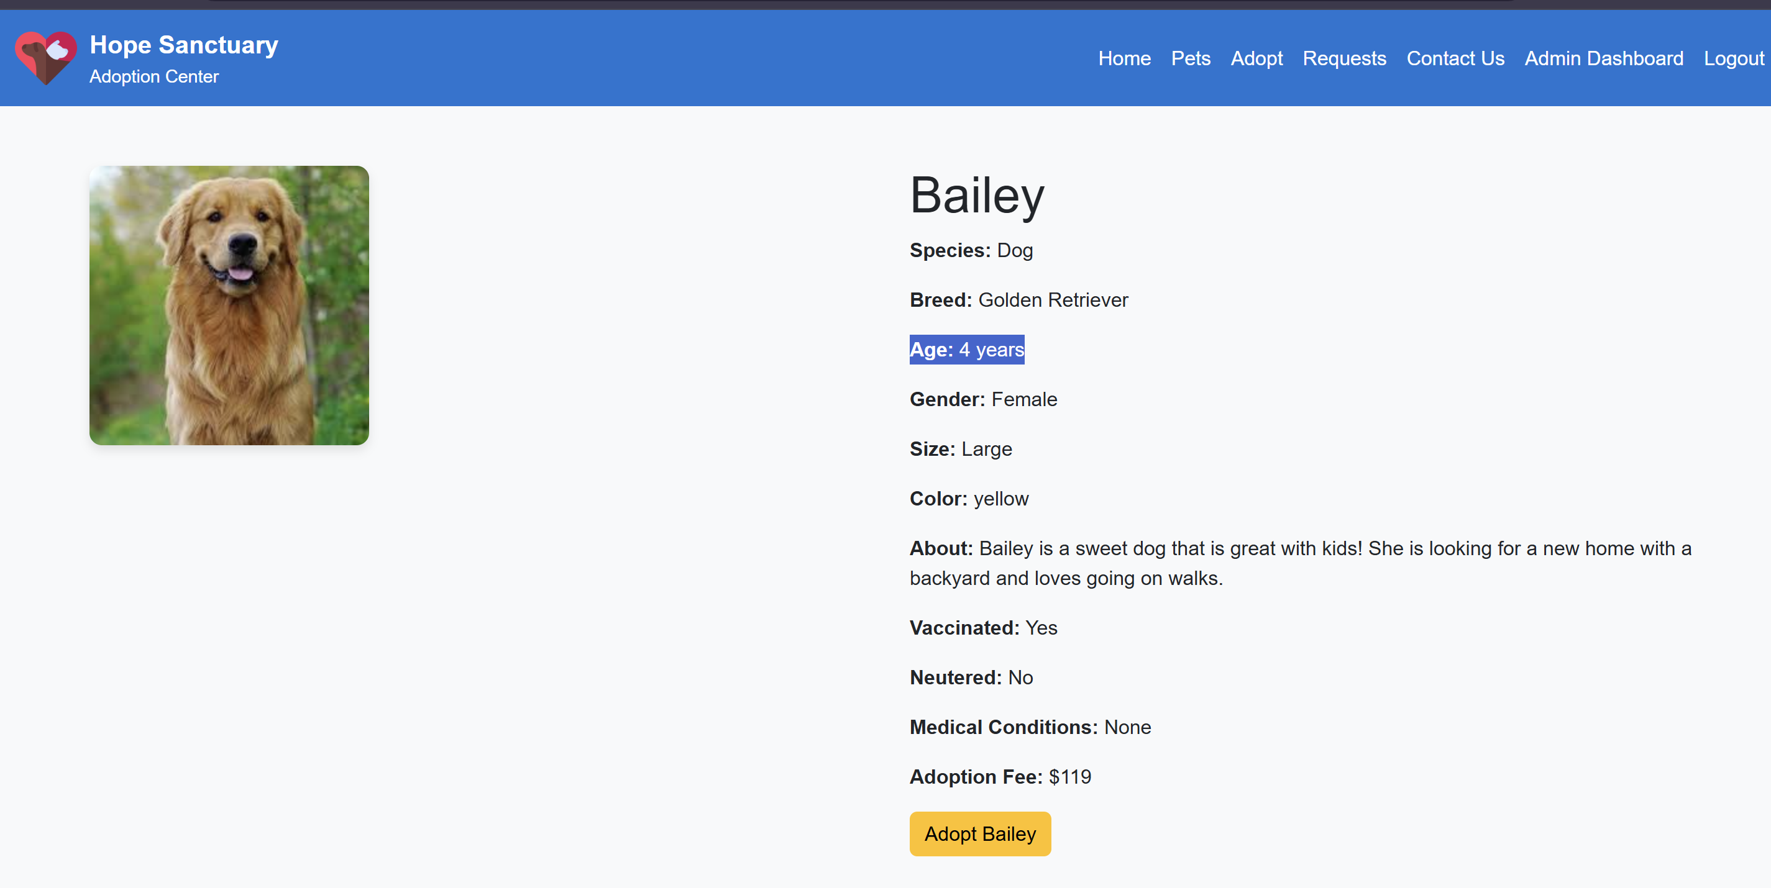

### Delete a pet

Step 1: login using the admin account. Refer to user guide above for login steps.

Step 2: navigate to the admin dashboard from the navigation bar.



Step 3: click on the delete pet button.



Step 4: confirm the deletion of the pet from the popup window. The pet will be deleted.

### View and change status of adoption requests

Step 1: login using the admin account. Refer to user guide above for login steps.

Step 2: navigate to the requests page from the navigation bar to view all the submitted requests.

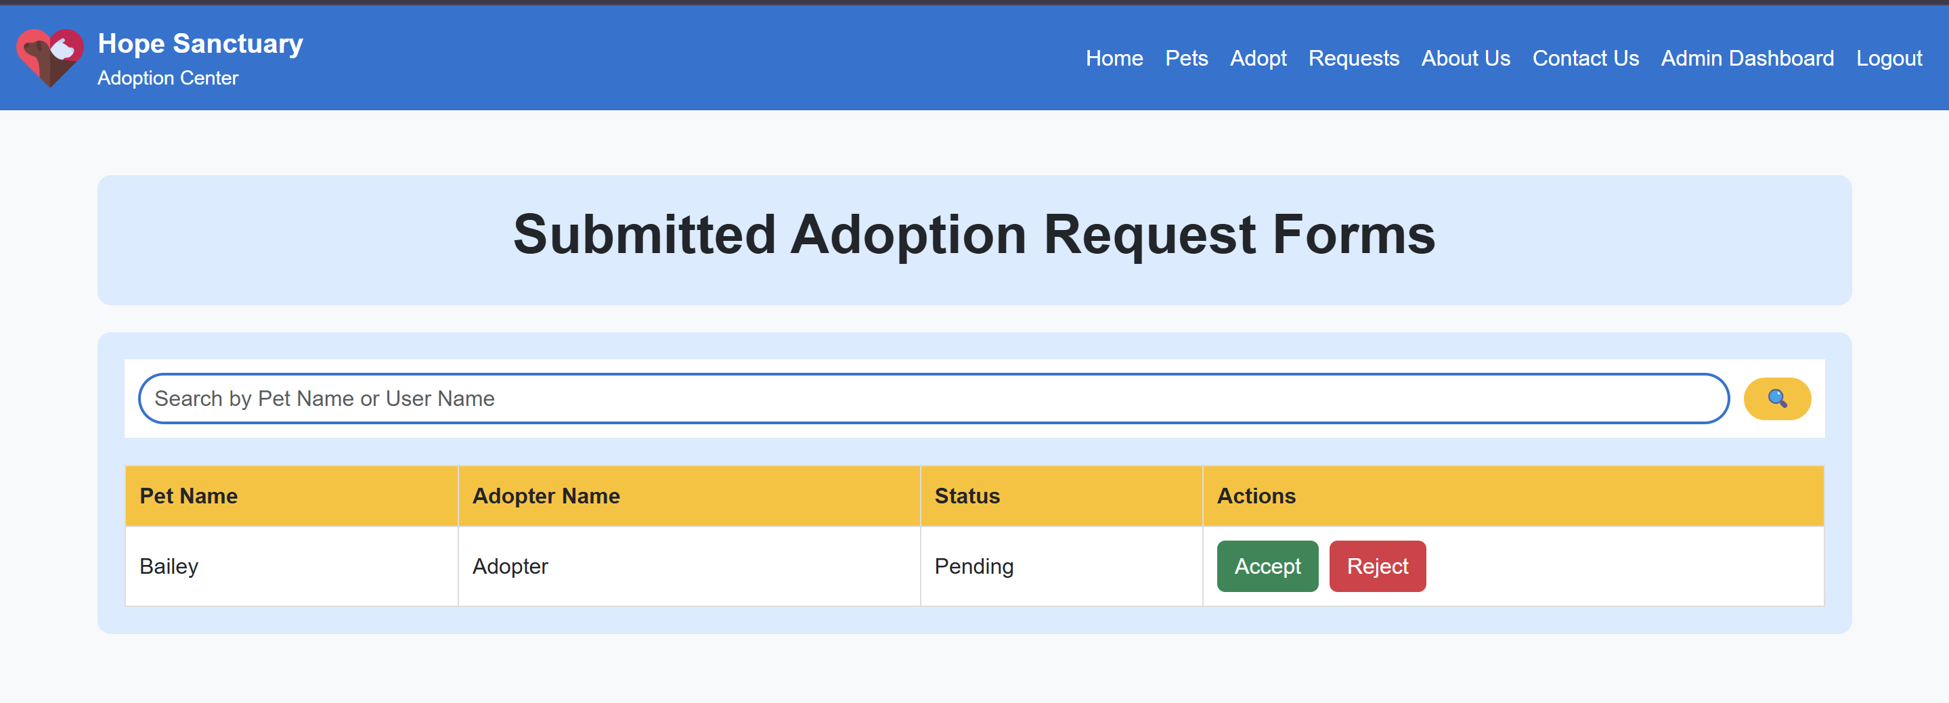

Step 3: to accept a request click on the accept button next to the request

Step 4: to reject a request click on the reject button next to the request.